

Project
Systems Requirements

 | Student Number | Surname | First Name
1 | 202402708 | Mokoena | Karabo
2 | 202306895 | Molomo | Karabo
3 | 202420029 | Thabethe | Kamohelo
4 | 202207325 | Thuto | Henderson

Table of Contents
- BUSINESS PROCESSES ............................................................................... 3
1.1 Food Delivery Logging Process .............................................................. 3
1.2 Delivery Confirmation Process ................................................................ 4
1.3 Inventory Management Process .............................................................. 4
1.4 Issue Reporting Process ........................................................................... 5
1.5 Monitoring and Decision-Making Process ..................................................... 5
1.6 Automated Alert and Tracking Process ....................................................... 6
- NON-FUNCTIONAL REQUIREMENTS ..............................................................7
2.1 Reliability ................................................................................. 7
2.2 Availability ................................................................................ 7
2.3 Security .................................................................................... 7
2.4 Performance ................................................................................. 7
2.5 Usability ................................................................................... 8
2.6 Maintainability ............................................................................. 8
2.7 Portability ................................................................................. 8
2.8 Scalability ................................................................................. 8
- FUNCTIONAL REQUIREMENTS .................................................................... 9
3.1 User Authentication ......................................................................... 9
3.2 Food Delivery Logging ........................................................................ 9
3.3 Delivery Confirmation and Issue Handling .................................................... 10
3.4 Inventory Management ......................................................................... 10
3.5 Daily Food Usage Recording ................................................................. 11
3.6 Expiry Monitoring and Alerts ............................................................... 11
3.7 Issue Reporting ............................................................................. 12
3.8 Manager Notification ........................................................................ 12
3.9 Monitoring and Dashboard Overview .......................................................... 12
3.10 Delay Detection and Alerts ................................................................. 13
3.11 Activity Logging ........................................................................... 13
- UML DIAGRAMS .................................................................................. 14
4.1 Use Case Diagram ............................................................................ 14

1. Business Processes
The system consists of three primary users: Delivery Driver, School Staff, and Nutrition Programme Manager. Each user interacts with a dedicated dashboard designed for their specific tasks.
At its core, the system:
Tracks, monitors, and manages the movement of food from suppliers to schools, and ensures it is properly received, stored, and used by learners.
In simpler terms:
- It records deliveries
- It tracks food stock
- It reports problems
- It gives government visibility
So, It turns a messy, manual process into a controlled, traceable system
The business processes below show how each user performs their tasks step-by-step using the system:

1.1 Food Delivery Logging Process (Delivery Driver Dashboard)
Process Description:
This process captures food deliveries at the point of arrival using the Delivery Driver Dashboard.
User Tasks:
- Delivery driver logs into the system
- Driver selects the school from the dashboard
- Driver enters delivery details (food type, quantity)
- System automatically records date and time
- Driver submits delivery record
- System stores delivery data in the central database
Outcome:
A real-time, accurate record of food delivery is created.

1.2 Delivery Confirmation Process (School Staff Dashboard)
Process Description:
This process ensures that delivered food is verified by school staff.
User Tasks:
- School staff logs into the dashboard
- Staff views pending deliveries
- Staff checks delivered items against physical stock
- Staff confirms delivery or reports discrepancies
- System updates delivery status
Outcome:
Deliveries are verified, and discrepancies are formally recorded.

1.3 Inventory Management Process (School Staff Dashboard)
Process Description:
This process tracks food stock levels and daily usage within the school.
User Tasks:
- School staff accesses inventory section
- Staff views current stock levels
- Staff records daily food usage
- System updates remaining stock automatically
- System monitors expiry dates
- System generates alerts for items nearing expiry
Outcome:
Stock levels remain accurate and food waste is reduced.

1.4 Issue Reporting Process (School Staff Dashboard)
Process Description:
This process allows schools to report missing, damaged, or delayed deliveries.
User Tasks:
- School staff selects “Report Issue”
- Staff chooses issue type
- Staff enters relevant details
- System logs the issue instantly
- System notifies the nutrition programme manager
Outcome:
Issues are reported in real time and can be addressed quickly.

1.5 Monitoring and Decision-Making Process (Manager Dashboard)
Process Description:
This process enables managers to monitor food distribution across all schools.
User Tasks:
- Manager logs into dashboard
- Manager views system overview (deliveries, stock, issues)
- Manager identifies discrepancies or delays
- Manager reviews reported issues
- Manager initiates corrective actions
Outcome:
Improved oversight, faster decision-making, and increased accountability.

1.6 Automated Alert and Tracking Process (System Functionality)
Process Description:
The system automatically supports users by monitoring data and generating alerts.
System Tasks:
- System tracks expiry dates
- System detects missing or delayed deliveries
- System sends alerts to relevant users
- System logs all user actions for accountability
Outcome:
The system enhances efficiency, reduces manual work, and improves transparency.

2. Non-functional requirements.

2.1Reliability
The system should operate reliably and precisely in standard conditions, without any failures.
- The system must be functional a minimum of 99% of the time.
- The system must not lose data when saving deliveries or stock.
- The system must display a clear error message when failures occur.
- The system must recover from minor failures automatically.
- All system errors must be logged for monitoring and maintenance purposes.

2.2 Availability
The system must be accessible to users when required.
- The system must be available 24/7 for administrators and government officials.
- School personnel must have the ability to access the system throughout school hours.
- The system must not be offline for longer than 2 hours each month.
- The system must support continuous online access across multiple locations

2.3 Security
The system must protect data and prevent unauthorized entry.
- Every user must log in with secure authentication credentials.
- User passwords must be encrypted before storage.
- Certain features must be available only to authorized users.
- The system must keep a log of every user action.
- Users must be logged out automatically after 5 minutes of inactivity.
- Confidential information must be safeguarded from unauthorized access.

2.4 Performance
The system must respond efficiently to user actions or activities.
- The system must respond to user inputs within 2 seconds.
- Updates on delivery and stock must be processed in less than 3 seconds.
- The system must be able to handle a minimum of 100 simultaneous users.
- Dashboard information must update within 5 seconds.
2.5 Usability
The system must be easy to use for all users.
- The system must offer a straightforward and easy-to-navigate interface.
- Users must be able to finish tasks in under 1 minute.
- The system must provide clear feedback messages to users.
- Navigation must be simple and consistent across all system interfaces.
- The system must require minimal user training.

2.6 Maintainability
The system must be easy to maintain and update.
- The system must be developed using well-structured and documented code.
- The system must follow a modular design approach.
- Identified issues must be resolved within 24 to 48 hours.
- System updates must not disrupt existing functionality.

2.7 Portability
The system must operate on different platforms and devices.
- The system must function on smartphones and tablets running Android and iOS.
- The system must be accessible through modern web browsers on computers.
- The system must accommodate various screen sizes and resolutions.
- The system must be easy to deploy in different settings.

2.8 Scalability
The system should accommodate future development and expansion.
- The system must accommodate growth in various schools across the country.
- The system must manage increased data without a decrease in speed.
- Upcoming versions of the system must accommodate a minimum of 500 simultaneous users.
- The system must enable the addition of new features without significant redesign.

3. Functional Requirements
3.1 User Authentication
Input:
- Username
- Password
- User role
Process:
- System validates login credentials
- System identifies user role (Driver, School Staff, Manager)
- System grants access to the correct dashboard
Output:
- User is logged in and redirected to role-specific dashboard

3.2 Food Delivery Logging
Input:
- Selected school (school_id)
- Food type
- Quantity
- Delivery date and time
Process:
- System records delivery details
- System links delivery to specific school and driver
- System stores data in delivery records
Output:
- Delivery is recorded with status “Pending Confirmation”

3.3 Delivery Confirmation & Issue Handling
Input:
- Delivery record
- Confirmation status (Confirm / Report Issue)
- Issue details (if applicable)
Process:
- System updates delivery status
- If confirmed → triggers inventory update
- If issue reported → logs issue and flags delivery
- System records user action for accountability
Output:
- Delivery marked as “Confirmed” OR “Issue Reported”
- Issue is stored and visible to manager

3.4 Inventory Management
Input:
- Confirmed delivery data
- Food quantities
Process:
- System adds delivered items to inventory
- System updates stock levels per school
- System maintains inventory records linked to expiry dates
Output:
- Updated and accurate food stock levels

3.5 Daily Food Usage Recording
Input:
- Food items used
- Quantity used
Process:
- System deducts used quantities from inventory
- System updates remaining stock
Output:
- Inventory reflects real-time stock after usage

3.6 Expiry Monitoring & Alerts
Input:
- Stored food items with expiry dates
Process:
- System continuously checks expiry dates
- System identifies items nearing expiry
- System generates alerts
Output:
- Notifications sent to school staff about expiring items

3.7 Issue Reporting
Input:
- Issue type (missing, damaged, delayed)
- Description
- Associated delivery or inventory
Process:
- System logs issue under specific school
- System timestamps and records reporting user
- System links issue to delivery if applicable
Output:
- Issue recorded in system for tracking and review

3.8 Manager Notification
Input:
- Newly reported issue or detected problem
Process:
- System sends alert/notification to manager
- System updates manager dashboard
Output:
- Manager is notified of issue in real time

3.9 Monitoring & Dashboard Overview
Input:
- Delivery records
- Inventory data
- Reported issues
Process:
- System aggregates data across all schools
- System organizes data into dashboard view
Output:
- Manager dashboard showing:
  - delivery status
  - stock levels
  - issues

3.10 Delay Detection & Alerts
Input:
- Expected delivery schedule
- Actual delivery timestamps
Process:
- System compares expected vs actual delivery times
- System identifies delays
Output:
- Alerts sent to relevant users about delayed deliveries

3.11 Activity Logging
Input:
- User actions (login, delivery entry, confirmation, edits, reports)
Process:
- System records:
  - user ID
  - action performed
  - timestamp
- System stores logs securely
Output:
- Complete audit trail of all system activities

4. UML diagrams
4.1 Use case diagram

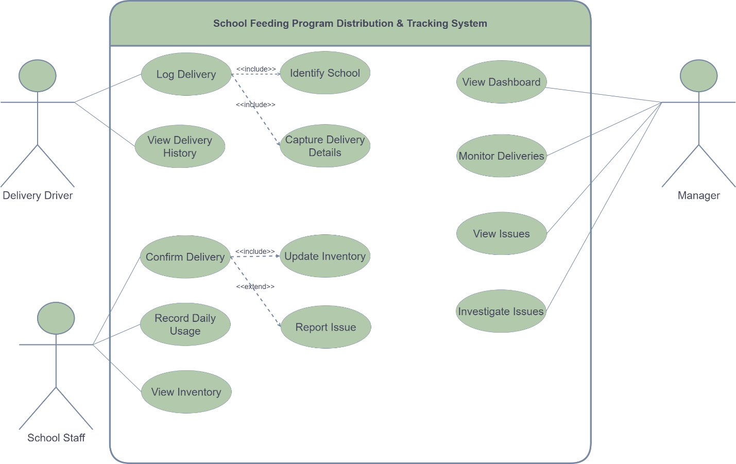

4.2 Activity diagram
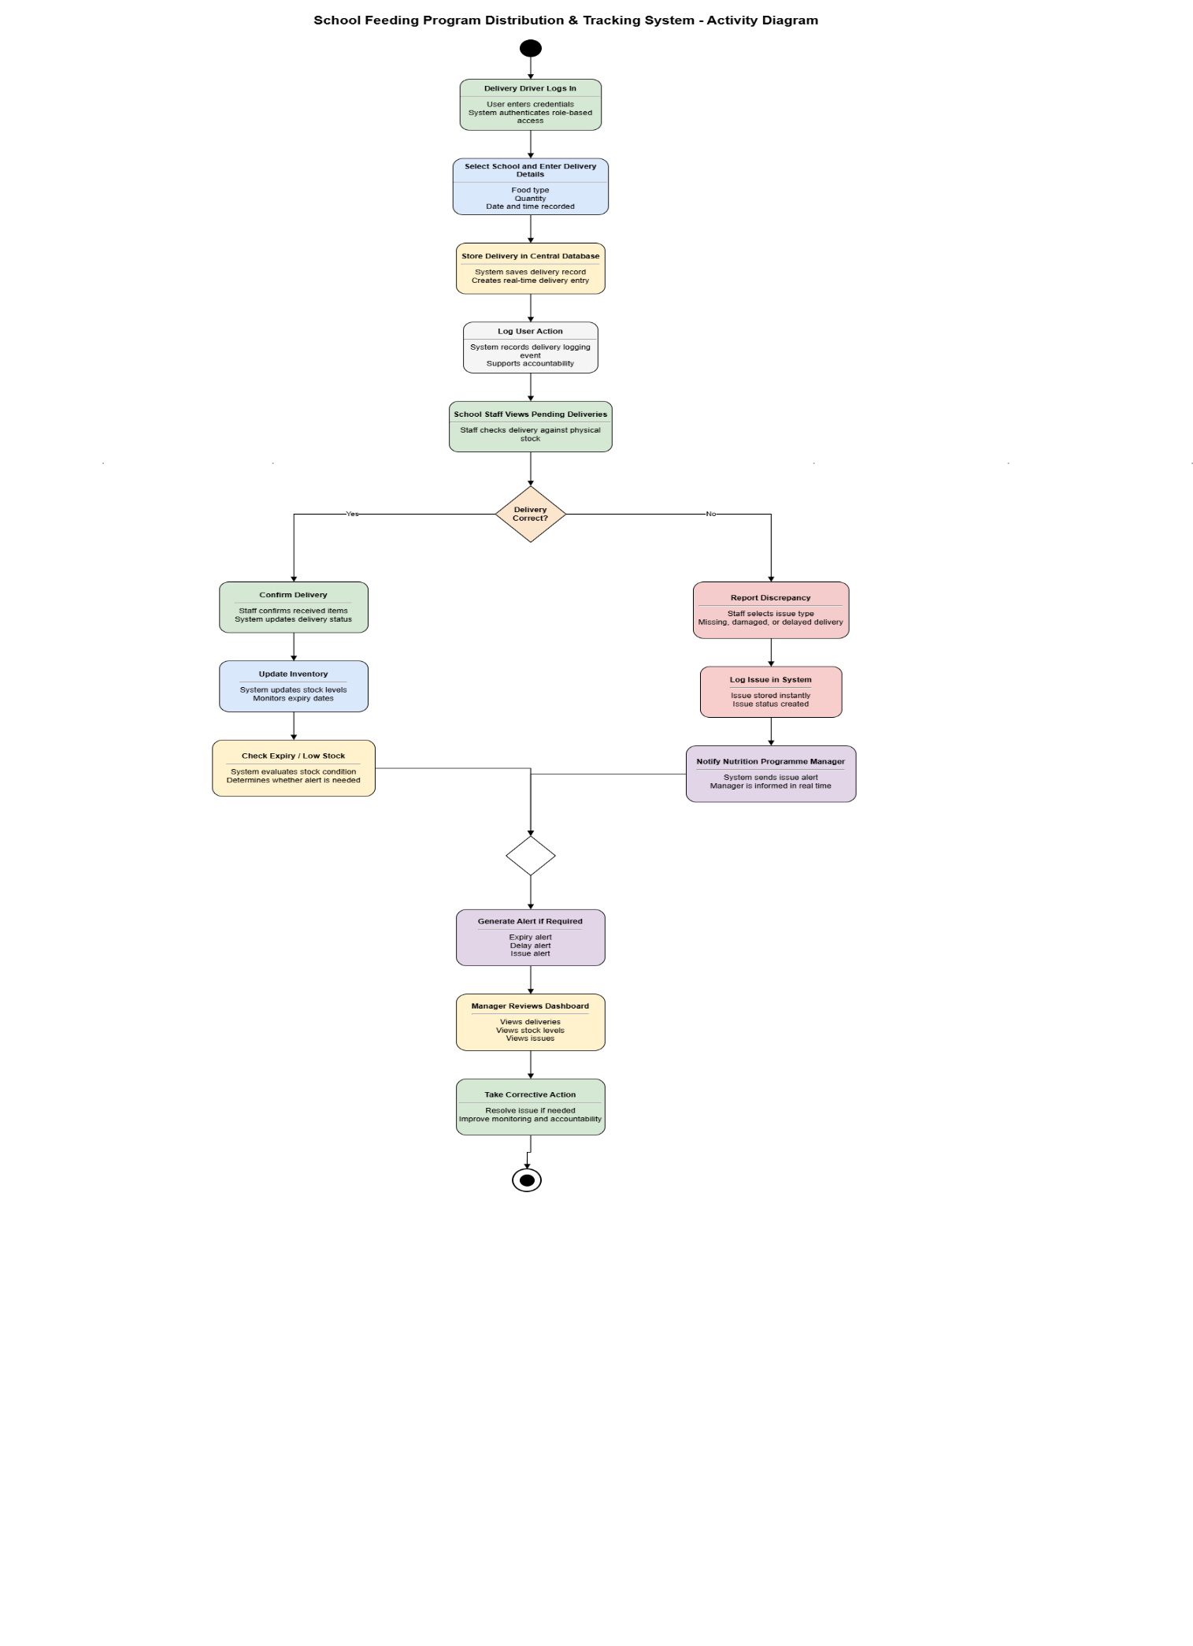
4.3 State diagram

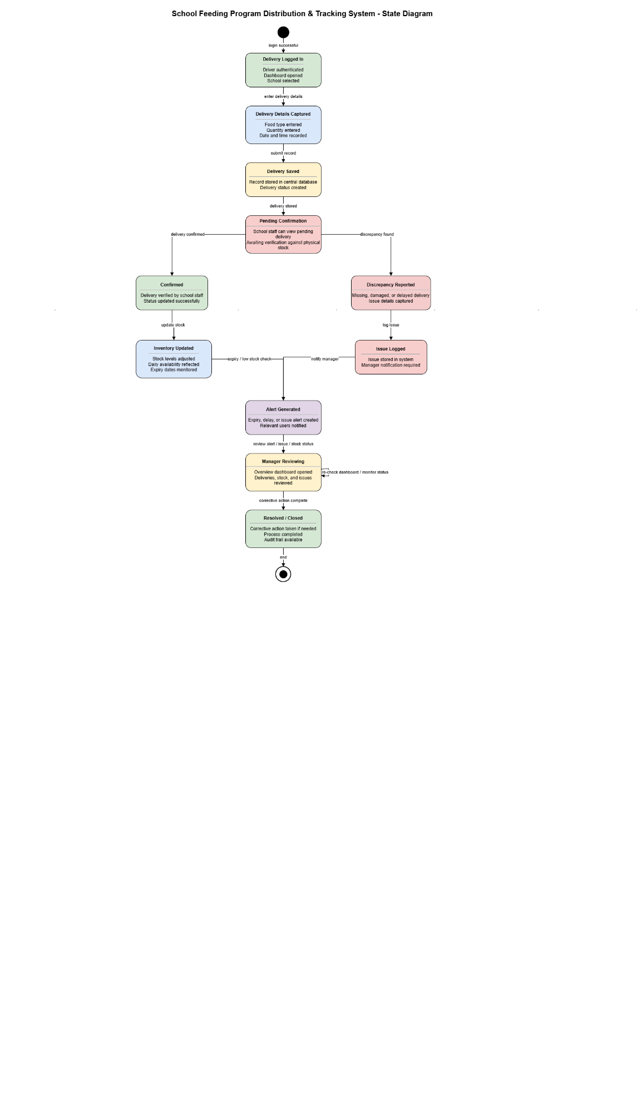

4.4 Class diagram

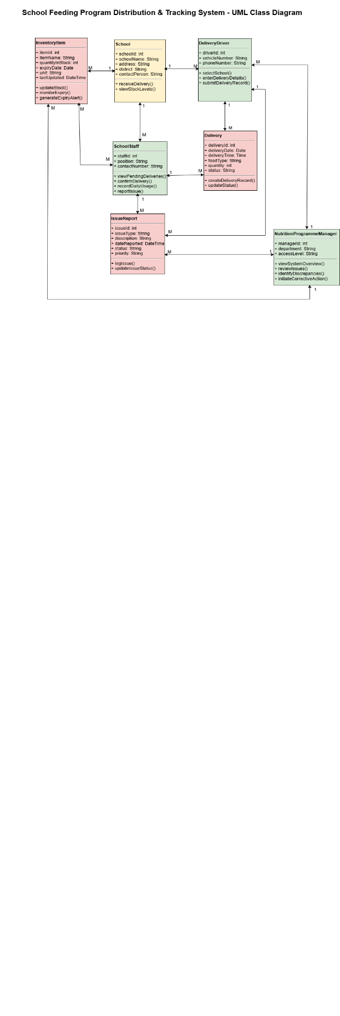

4.1 Sequence diagram

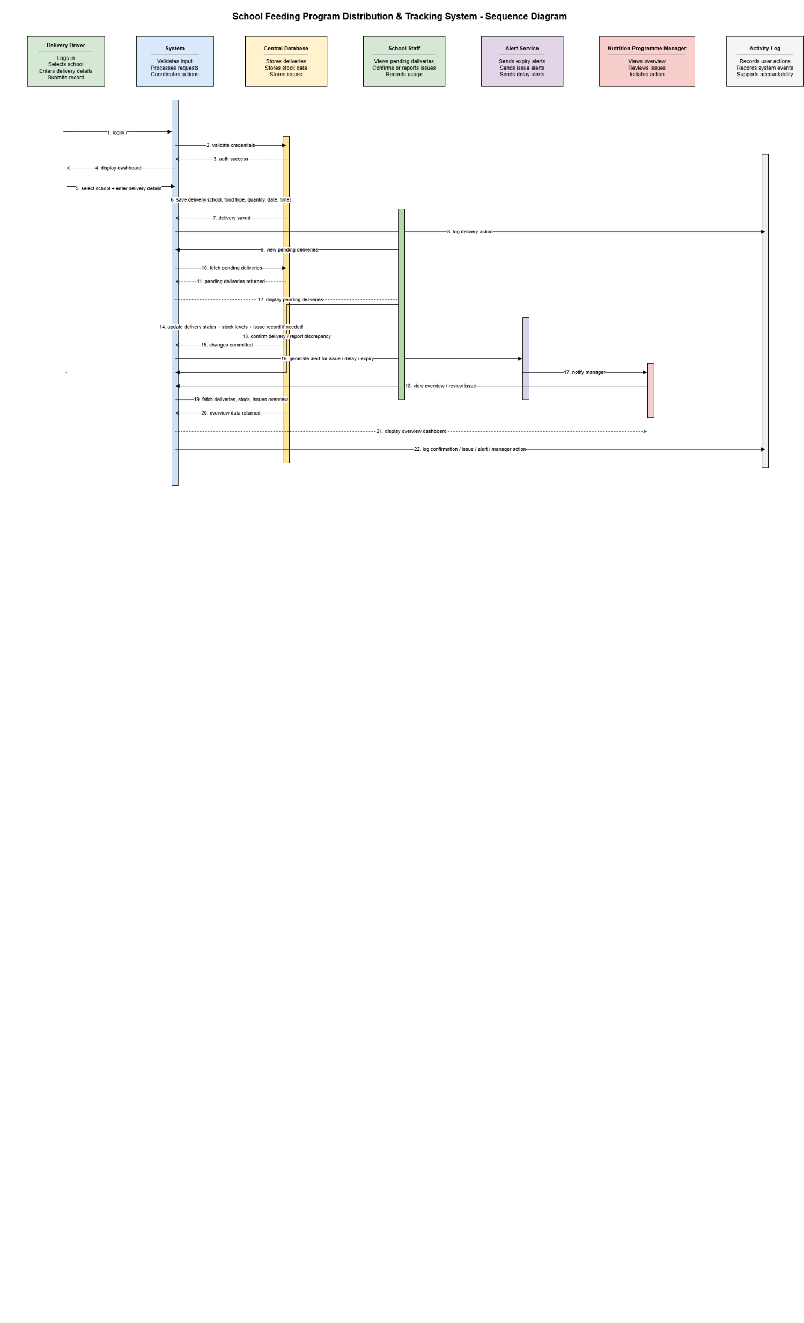

5. Work Breakdown Structure

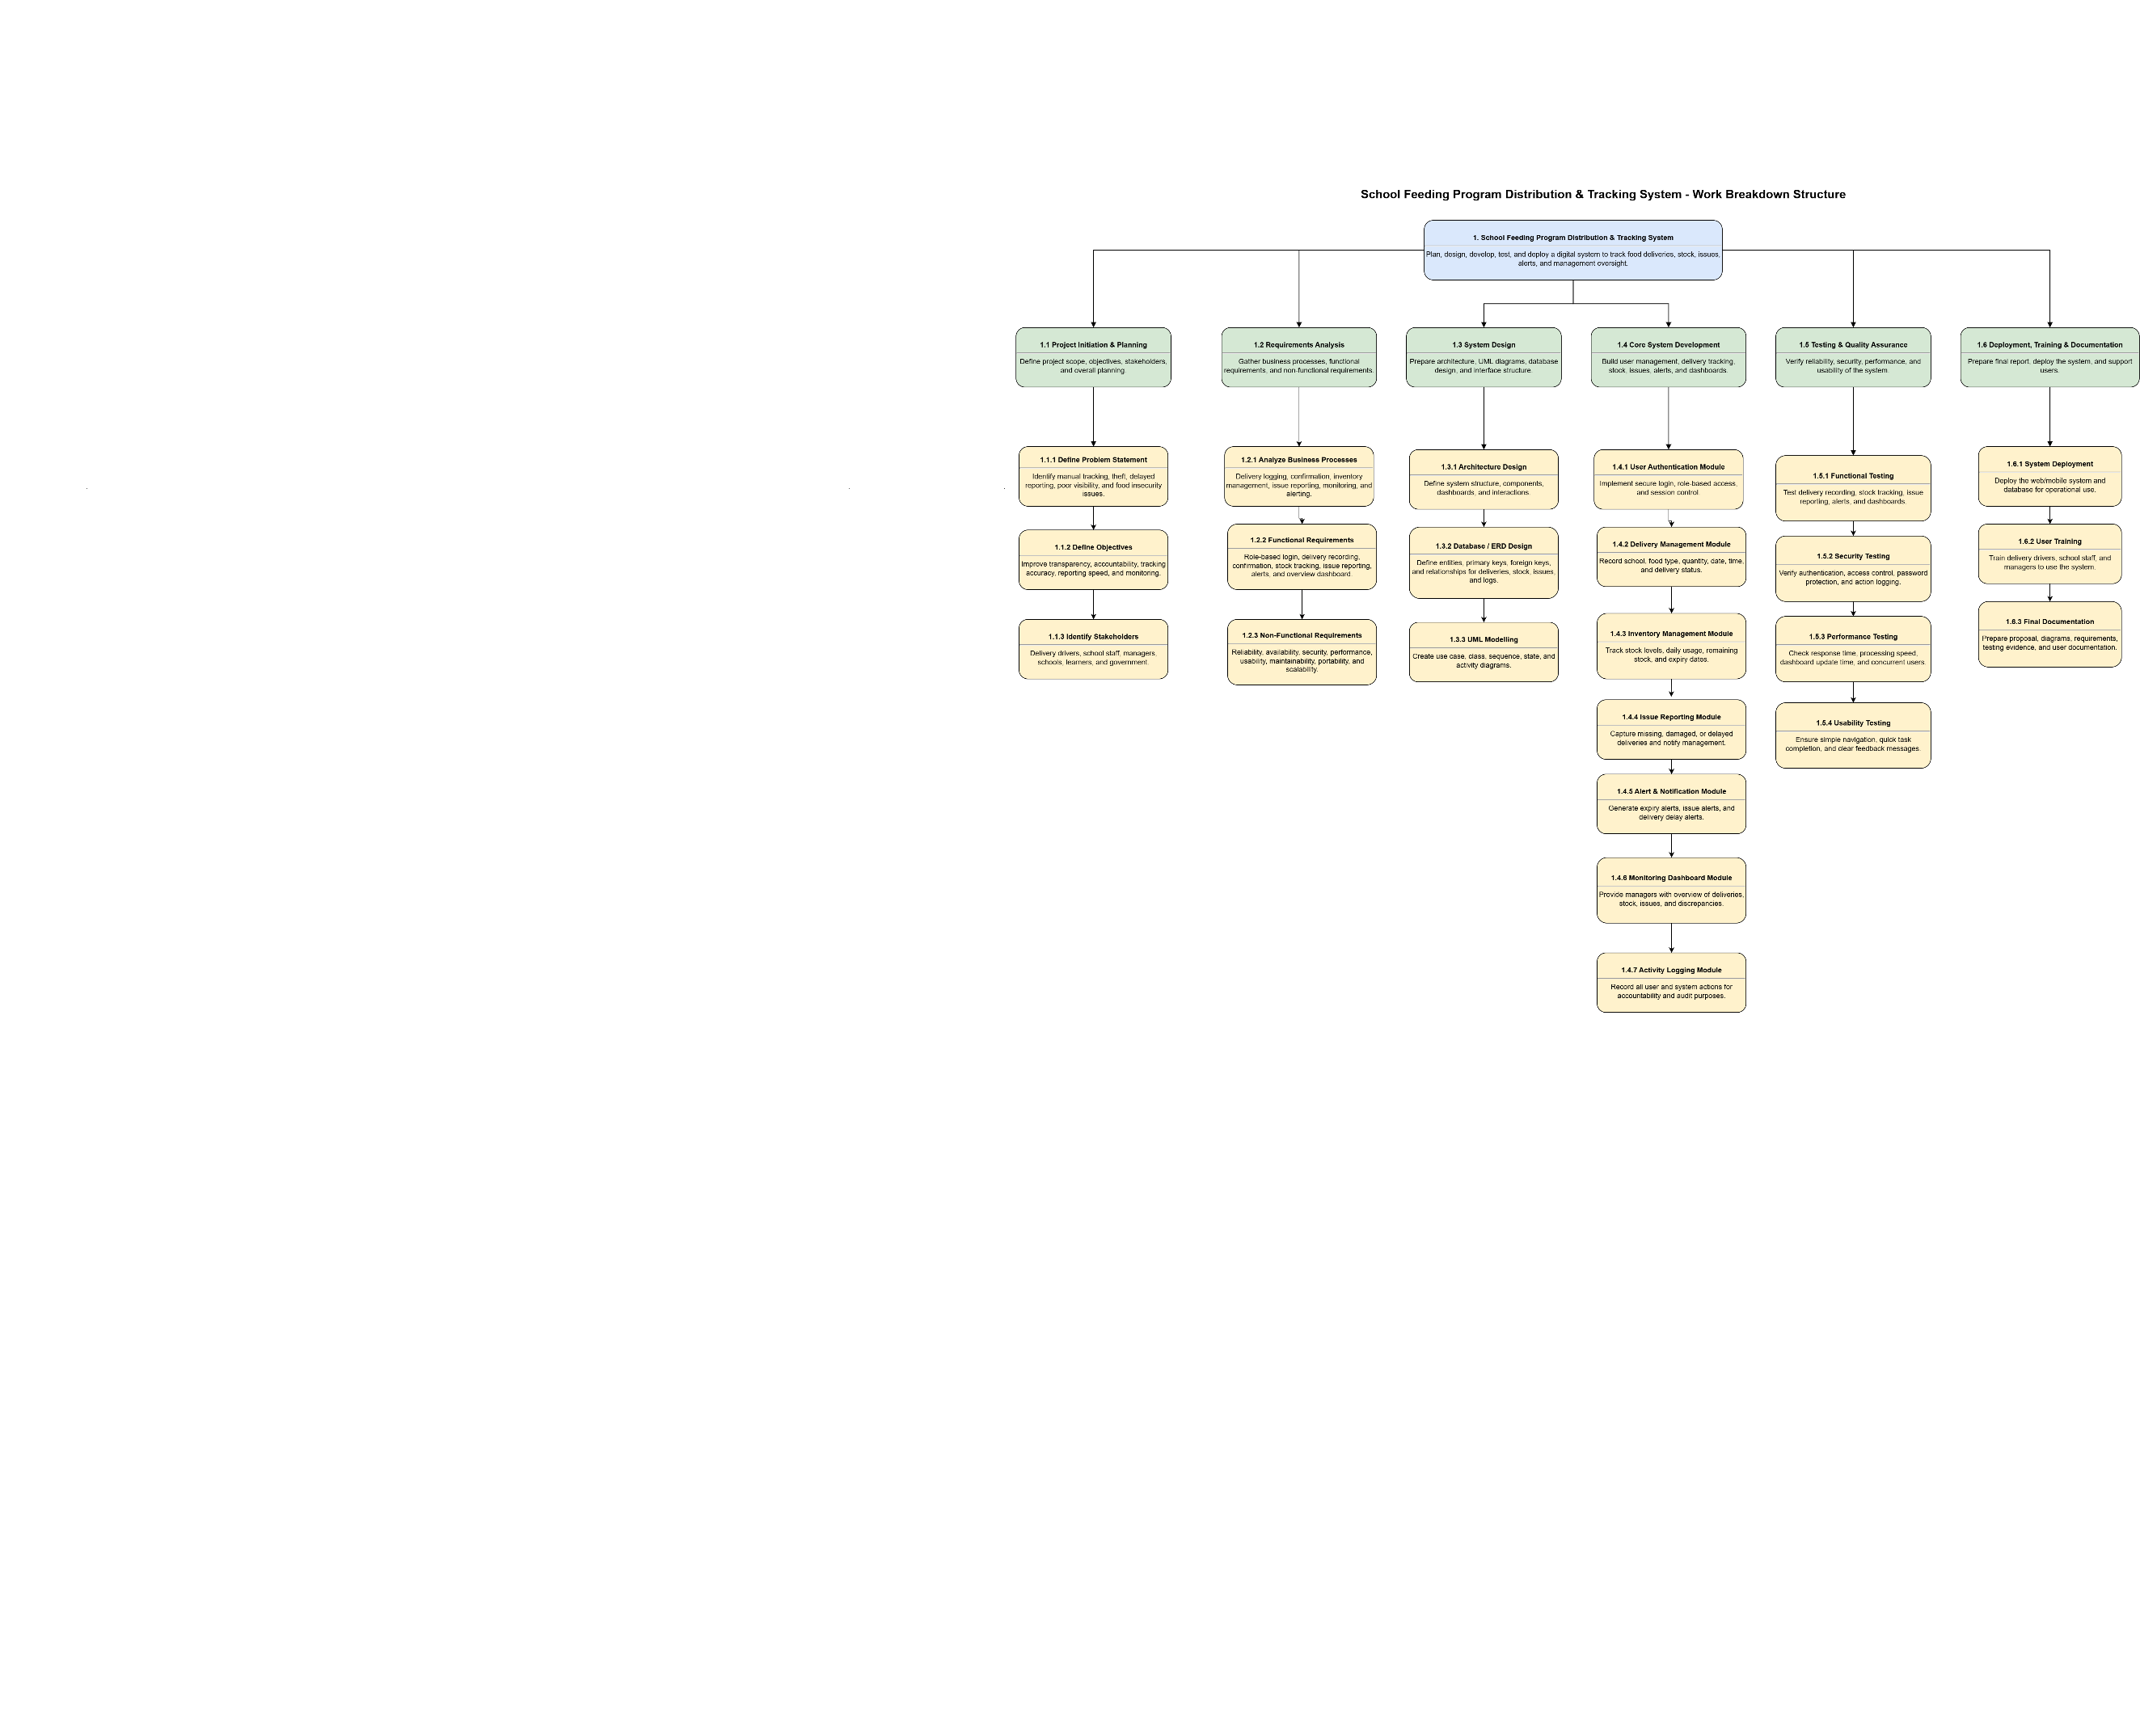

4. Gantt chart

